PROGRESSIVE DAMAGE ANALYSIS OF COMPOSITE

LAMINATES WITH BIG CUTOUTS 1）

Chu Pengcheng, Li Zheng2), Chen Jianlin

(*College of engineering & LTCS, Peking university*，*Beijing 100871，China* )

**Abstract：**Composite materials have been increasingly used in practical engineering, many of which are designed as large aperture composite laminates, such as aircraft gates and portholes. Due to its complex stress state and the effect of stress concentration, coupled with the anisotropic nature of the composite material itself, various complex failure modes are produced, which leads to the difficulty in predicting the damage of laminates with big cutouts. In this paper, the progressive damage model is used to numerically simulate the damage of composite laminates with different cutouts and different layup under tensile loading. The Hashin criterion is used to judge whether the laminate has been damaged, and the continuum damage model(CDM) is used to simulate the progressive failure process of the damaged laminate. At the same time, shear nonlinear theory is introduced to perfect the model. We use ABAQUS finite element software, through the UMAT subroutine program written in Fortran to introduce progressive failure calculation model, calculate the ultimate load of the composite laminates with big cutouts, and simulate the entire process from the initial failure to complete failure of the laminate. Comparing the calculated results with the experimental results, the damage evolution mechanism and rules in the process of laminate destruction can be finally obtained. It also verifies that the calculation method in this paper can accurately predict the ultimate load and damage behavior of composite laminate with big cutouts under tensile load.

**Key words**：composite laminate, big cutout, progressive failure, continuum damage model, shear nonlinearity

**Introduction**

Because composite materials have the advantages of high specific strength, designability, fatigue resistance, and high temperature performance[1], they are widely used in aerospace, energy, transportation, construction and other engineering fields. At the same time, the composite laminates containing holes are also widely used in engineering, such as the bolt holes at the joints of laminates and the observation holes and bleed holes on aircraft engines. In addition, in order to meet the actual functions and requirements in production, there are a large number of structures designed to be laminates with big cutouts, such as aircraft fuselage doors and windows. However, it is unavoidable that it causes damage and failure to the structure during use. Composite materials have non-uniformity and anisotropy, and their destruction process is very complicated. There are four main types of composite material damage: 1 matrix cracking 2 interface debonding 3 delamination 4 fiber breakage. Sometimes different combinations of these four types of damage can form a comprehensive damage. As the damage area and size continue to increase, macroscopic cracks develop and expand, eventually resulting in final failure of the structure. For composite laminates with big cutouts, the internal stress state is more complicated. At the same time, due to the concentration of stress at the edge of the cutout and the discontinuity of the fiber at the cutout, the evolution process of the damage and the failure mode are further complicated. Therefore, it is very important and meaningful to accurately predict the damage state and ultimate load of composite laminates with big cutouts and explore the mechanism of damage for the safety and reliability of composite materials in engineering applications[2, 3].

At present, the methods developed for the failure calculation of composite laminates with cutouts fall into two major categories: analytical analysis and numerical calculation. The classic method of analytical analysis is to use fracture mechanics-based methods to predict the failure of laminates. For example, Whitney and Nuismer[4] proposed two methods for calculating the tensile strength of composite laminates based on the stress field distribution using characteristic scales: point stress method and average stress method. This method, without the need for complex calculations, has successfully predicted the failure of laminates under stress concentration, and also accurately simulated the size effect of laminates. However, this method based on fracture mechanics requires a large amount of experimental data, and most theories can only be used to calculate open laminates for a specific layup. At the same time, its limitation is that it only applies to composite laminates with small cutouts. As soon as the size of the cutout of the laminate increases, many assumptions of fracture mechanics no longer hold, then this method is no longer suitable.

Analytic methods in damage theory are not applicable to composite laminates where the stress state is more complex. On the other hand, the limitation of this method is that they can only calculate the ultimate load of laminates and cannot simulate the damage process of laminates. To understand the mechanism of composite laminates with big cutouts from initial damage to complete destruction, numerical damage analysis methods are clearly more applicable.

In numerical damage theory, a common analysis method is to use a progressive damage model. A large number of experimental data show that the failure of composite laminates is usually a gradual process, so we can see the gradual degeneration of stiffness as a function of failure modes. The study of Ochoa and Reddy [5] shows us the basic steps of progressive damage analysis of composite materials, as shown in Figure 2. This type of method usually consists four main steps[6]: (I) Strain and stress analysis in single layer of laminates. The key issue here is the establishment of the constitutive equations. Usually we use the finite element method to perform this step of calculation. (II) We use the failure criterion to determine whether the lamina has failed. Different researchers have proposed many different failure criteria, including the well-known maximum stress criterion, Tsai-Wu criterion[7], Hashin-Rotem criterion[8], and Puck criterion[9]. If it is judged that the material has not failed, then continue to increase the load to repeat the above calculation, if there is a failure, proceed to the next step; (III) the progressive failure analysis after the material has failed. The material stiffness of a single layer that has failed is reduced. The commonly used methods for this step are the ply discount method[10] and the continuum damage method[11] method, which will be described in detail below; (IV) Judging the complete failure of the laminate structure.. Some researchers believe that when the fiber damage occurs in each layer of the laminate, the laminate completely fails. However, this does not hold true in the case of stress concentration. For example, in open laminates, local fiber breaks can actually relieve stress concentration[12]. Camanho et al[13] believe that when the failure of the laminates expands to its boundary, the laminate fails completely. This paper uses this method to determine the ultimate failure of the laminate.

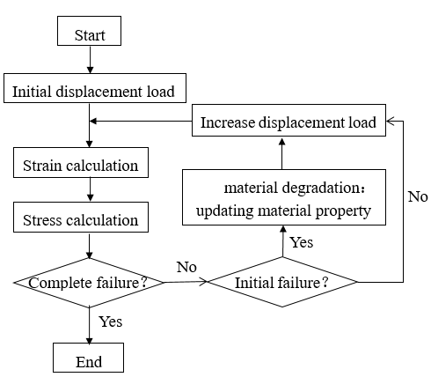

Fig.1 Progressive damage analysis process

From the above discussion, it can be seen that the analytic analysis method is often not applicable to composite laminates with big cutouts where the stress state is more complex. On the other hand, the limitation of these method is that they can only calculate the ultimate load of laminates and cannot simulate the failure process of laminates. To understand the mechanism of composite laminates with big cutouts from initial damage to complete destruction, numerical damage analysis methods are clearly more applicable. The numerical calculation method based on the continuous damage model and the finite element method is applicable to the damage analysis of any structure under any load form. It effectively compensates for the shortcomings of the analytical methods.

In the CDM, we describe the internal damage of composite material by defining one or more internal state variables, and set the coefficients in the constitutive relation as a function of one or more internal state variables. Krajcinovic[11] first proposed the idea of ​​CDM, describing it as a branch of continuous solid mechanics, in which the internal field variables represent the distribution of local microcracks. Shahid[14] and other scholars[15-16] applied this model earlier to composite laminates. Maimí[17] used the CDM to predict the initiation and evolution of the failure within the composite layer and the ultimate damage of the structure. Lapczyk et al[18] used the Hashin criterion and the CDM to predict the failure and post-failure behavior of the fiber-reinforced composites and calculate the elasto-brittle fracture behavior. Lee and Kim et al[19] evaluated the initial and progressive failures of glass/carbon fiber reinforced composite laminates based on the puck criterion and damage mechanics methods, and obtained results that are in good agreement with the experimental results.

The continuous damage model based on the theory of damage mechanics effectively avoids the uncertainty of the material degradation coefficient in the ply-discount model. All of the parameters it uses have a clear physical meaning and can all be measured directly and have proven to be a more effective and reliable method of simulating laminate damage.

At present, the damage study of composite laminates is concentrated in laminates without cutouts or small cutouts, but for composite laminates with big cutouts, there is a relative lack of simulations and calculations. Moreover, the damage of composite materials in the past is often focused on the prediction of the ultimate load, and the mechanism of the entire process from the initial failure to the complete failure is less studied, and this is exactly the limitations of some analytical methods.

In this paper, the progressive damage model which is formed by Hashin criteria and CDM is used to numerically simulate the damage of composite laminates with different cutouts and different layup under tensile loading. Through the comparative analysis of experiments and calculations, the ultimate load and damage evolution process of the composite laminates with big cutouts were obtained, the damage mechanism was revealed, and the reliability of the calculation model was also verified.

**1 Progressive damage analysis model**

**1.1 Failure criteria**

The strength criteria of the composite material is the basis for determining whether the material is damaged. In this paper, the Hashin-Rotem criteria is used to judge the damage of the laminate with big cutouts. As a failure criterion related to the failure mode, The failures of composites were divided into four types of damage modes: fiber tensile, (ft), fiber compression (fc), matrix tensile (mt), and matrix compression (mc):

(I) fiber tensile failure:

|  |  |  |
| --- | --- | --- |
|  | $${f_{ft}=\left(\frac{σ_{11}}{X_{T}}\right)}^{2}≥1 (σ_{11}>0)$$ | (1) |

(II) fiber compression failure:

|  |  |  |
| --- | --- | --- |
| $${f_{fc}=\left(\frac{σ_{11}}{X_{C}}\right)}^{2}≥1 (σ_{11}<0)$$ |  | (2) |

(III) matrix tensile failure:

|  |  |  |
| --- | --- | --- |
| $${f_{mt}=\left(\frac{σ_{22}}{Y_{T}}\right)}^{2}+{\left(\frac{σ_{12}}{S_{12}}\right)}^{2}≥1 (σ_{22}>0)$$ |  | (3) |

(IV) matrix compression failure

|  |  |  |
| --- | --- | --- |
| $${f_{mc}=\left(\frac{σ_{22}}{Y_{C}}\right)}^{2}+{\left(\frac{σ_{12}}{S_{12}}\right)}^{2}≥1 (σ_{22}<0)$$ |  | (4) |

In the formula, XT (XC) is the tensile (compression) strength of the single layer in the fiber direction; YT (YC) is the tensile (compression) strength of the single layer in the matrix direction; S12 is the transverse shear strength of the single layer.

**1.2 Damage constitutive equation**

Once the material reaches the conditions of the strength criterion, the material stiffness coefficient is then degraded. In this paper, the continuum damage model is used to calculate the reduction of the material stiffness coefficient. When the material fails, the constitutive relationship of the material is defined by the damage stiffness matrix C:

$$C=\frac{1}{D}\left[\begin{matrix}(1-d_{1})E_{1} & (1-d_{1})(1-d_{2}){ν_{21}E}_{1} & 0 \\ (1-d_{1})(1-d_{2}){ν_{12}E}_{2} & (1-d_{2})E_{2} & 0 \\ 0 & 0 & D(1-d_{6})G_{12}\end{matrix}\right]$$

(5)

$d_{1}$， $d_{2}$ and $d_{6}$ in equation (5) are damage variables and all belong to scalars. They are set to maintain the symmetry of the material under damage conditions. The damage variable $d_{1}$ is related to the failure of the longitudinal (fiber), $d_{2}$ is related to the failure of the transverse (matrix), and $d_{6}$ is affected by the transverse and longitudinal cracks at the same time. The expression of D is: $D=1-\left(1-d_{f}\right)\left(1-d_{m}\right)ν_{12}ν_{21}$, parameters $E_{1}$， $E_{2}$ and $G_{12}$ are the elasticity modulus when the material is not damaged, and $ν_{21}$ and $ν_{12}$ are the poisson ratio of undamaged materials.

**1.3 Failure evolution**

The evolution of the damage is controlled by the damage variable. From the initial failure to the complete destruction of the material, the damage variable gradually changes from 0 (undamaged state) to 1 (complete destruction). The researchers proposed different damage variable evolution rules to simulate the softening process of material damage. For example, Camanho et al[17] proposed the use of an exponential form of evolution rule to characterize the failure behavior, while Lapczyk et al[18] assumed that the evolution of the damage follows a linear law. Different forms of degradation laws apply to different materials, as shown in Figure 2. In this paper, two kinds of evolution laws, namely exponential and linear, are used respectively to degenerate the damage variable, and the results are compared. Here we take four damage variables corresponding to the four damage models in the Hashin criterion, *ft* and *fc* represent the tensile and compression failure of the fibers respectively, and *mt* and *mc* represent the tensile and compression failure of the matrix respectively. The expressions listed according to the linear and exponential evolution rules are:

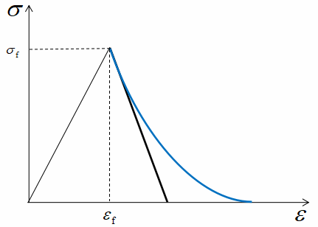

Fig.2 Damage evolution law (black: linear law; blue: exponential law)

（I）linear evolution:

$d_{I}=A\left(1-\frac{1}{f_{I}}\right) I∈\left\{ft,fc,mt,mc\right\}$ (6)

（II）exponential evolution:

$d_{I}=1-\frac{1}{f_{I}}e^{A\left(1-f_{I}\right) }I∈\left\{ft,fc,mt,mc\right\}$ (7)

Where A is the expression of the material parameters related to the strength and the fracture energy, and $f_{I}$ corresponds to the failure criterion expression under four different failure modes in equations (1) to (4) respectively. Integrating the energy dissipation rate can obtain the energy dissipation value $g_{I}$ in the unit volume under the uniaxial stress state:

$g_{I}=\int_{1}^{∞}{\frac{∂G}{∂d_{I}}\frac{∂d_{I}}{∂f_{I}}df_{I} I∈\left\{ft,fc,mt,mc\right\}}$ (8) By Equation (8), the parameter A in equations (6) and (7) can be calculated to determine the expression of the damage variable $d_{I}$.

**1.4** **Characteristic length method**

Due to the strain softening behavior of the material in the calculation, the localization of the strain results in a strong mesh dependence of the finite element results. Lapczyk[18] used the example of uniaxial tensile of the bar to show that the dissipated energy is proportional to the volume of the failed element. In order to avoid the occurrence of different dissipative energy using different element sizes in the results, he used the crack band model proposed by Bažant et al. [20]. In this model, the fracture is modeled as a parallel tightly distributed microcrack band zone. In order to eliminate the dependence of the mesh, the characteristic length of the element is introduced so that the calculated dissipation energy can be regularized:

$g_{I}=\frac{G_{I}}{L_{c}} I∈\left\{ft,fc,mt,mc\right\}$ (9)

In the formula, $G_{I}$ is the fracture energy, $L_{c}$ is the characteristic length of the element, and $g_{I}$ is the fracture energy in the unit volume. Combine equation (8) to get:

$\int_{1}^{∞}{\frac{∂G}{∂d_{I}}\frac{∂d_{I}}{∂f_{I}}df_{I}=\frac{G_{I}}{L_{C}} I∈\left\{ft,fc,mt,mc\right\}}$ (10)

Combining equations (6), (7) and (10), the expressions of the damage variable under the two laws of linear evolution and exponential evolution can be obtained:

( I ) Linear evolution

$d_{fM}=\frac{2G_{f}C_{11}}{2G_{f}C_{11}-X_{fM}^{2}L_{C}}\left(1-\frac{1}{f_{fM}}\right) M∈\left\{t,c\right\}$ (11)

$d_{mM}=\frac{2G_{m}C_{22}}{2G_{m}C_{22}-Y_{mM}^{2}L_{C}}\left(1-\frac{1}{f_{mM}}\right) M∈\left\{t,c\right\}$ (12)

( II ) Exponential evolution

$d_{fM}=1-\frac{1}{f_{fM}}e^{\frac{X_{fM}^{2}L_{C}}{C_{11}G_{f}}\left(1-f_{fM}\right) } M∈\left\{t,c\right\}$

(13)

$d_{mM}=1-\frac{1}{f_{mM}}e^{\frac{Y_{mM}^{2}L_{C}}{C_{22}G_{m}}\left(1-f_{mM}\right) } M∈\left\{t,c\right\}$

(14)

Here, $G_{f}$ and $G_{m}$ are the fracture energy of the fiber and the matrix, respectively, and the letter M in the subscript is t or c respectively indicating the state of tension or compression. $C_{ij}$ is the coefficient of the stiffness matrix.

**1.5 Shear nonlinearity**

In general, when we consider the stress-strain relationship of composite materials, we only consider the linear elastic constitutive equation. However, a large number of experimental data in recent years show that there are nonlinear the mechanical behavior of laminates. In the study of Puck et al[9], they used a large number of experimental results to show us the nonlinear phenomenon of the stress-strain relationship of composite materials under various types of loads. In many nonlinear studies, plane shear experiments are the most promising examples of nonlinear effects[21-23]. The shear nonlinearities in composites have been widely accepted, and many researchers have considered shear nonlinear effects in material modeling[24-26]. Among them, Liu Weiguang et al[27] used the Ramberg-Osgood equation[28] to fit the nonlinear relationship between shear strain and shear stress. The specific expression is as follows:

$τ=\frac{G_{0}γ}{{\left[1+{\left(G_{0}γ/τ_{0}\right)}^{n}\right]}^{1/n}}$ (15)

In the formula, τ and γ are the shear strain and the shear stress respectively, $G_{0}$ is the initial shear modulus, $τ_{0}$ is the ultimate shear strength, and n is the parameter that defines the shape of the shear nonlinearity curve. From equation (15), the constitutive relation of the composite material considering shear nonlinearity can be obtained:

$$\left[\begin{matrix}σ_{1} \\ σ_{2} \\ τ\end{matrix}\right]=\left[\begin{matrix}\frac{E_{1}}{1-ν_{12}ν_{21}} & \frac{ν_{21}E_{2}}{1-ν_{12}ν_{21}} & 0 \\ \frac{ν_{12}E_{1}}{1-ν_{12}ν_{21}} & \frac{E_{2}}{1-ν_{12}ν_{21}} & 0 \\ 0 & 0 & \frac{G_{0}}{{\left[1+{\left(G_{0}γ/τ_{0}\right)}^{n}\right]}^{1/n}}\end{matrix}\right]\left[\begin{matrix}ε_{1} \\ ε_{2} \\ γ\end{matrix}\right]$$

(16)

In the numerical simulation of this paper, the constitutive model in the material is calculated according to equation (16) before the initial failure of the composite laminate. Once a damage occurs in a certain area of the composite material, the constitutive model of the area is shown in equation (5).

**2 Numerical simulation of damage of laminates with big cutouts**

**2.1 Damage evolution simulation of laminates with big cutouts**

This paper uses ABAQUS finite element software and UMAT subroutines written in Fortran to introduce the progressive failure calculation model. Numerical simulations of different layups and different apertures of composite laminates with big cutouts under tensile load were performed. The three types of layups are ${[0]}_{10}$ unidirection-ply layup, ${[0/90]}_{5}$ cross-ply layup and ${[45/-45]}_{5}$ angle-ply layup. At the same time, the laminate of each layup is divided into three different apertures of 60mm, 80mm and 100mm. The dimensions of the laminates are all 240 mm×160 mm×1.58 mm, and the load type is uniaxial tensile as shown in Fig 3.

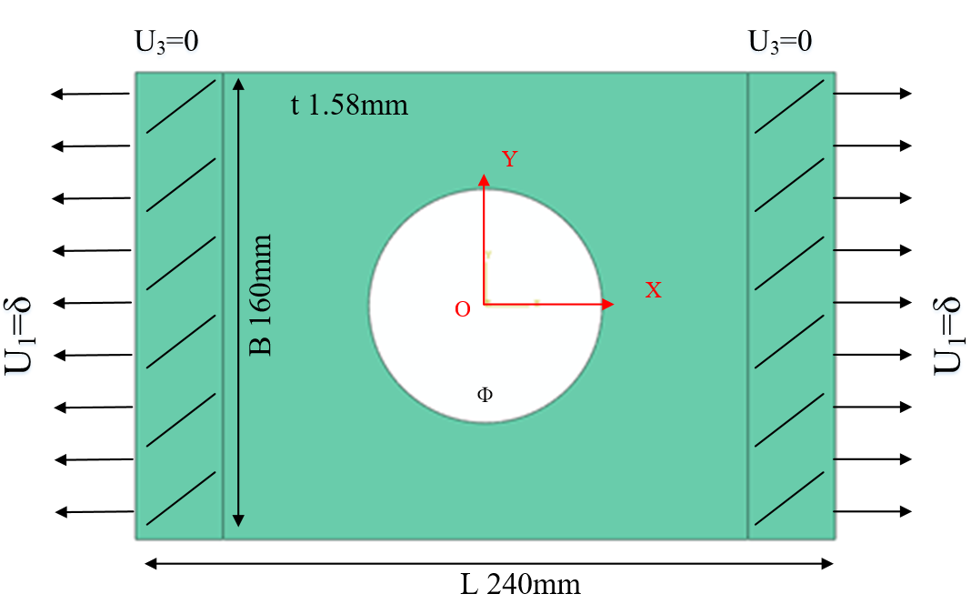

Fig.3 Simulation model

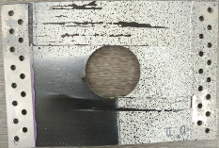 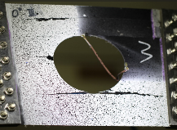 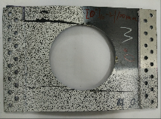

1. [0]10

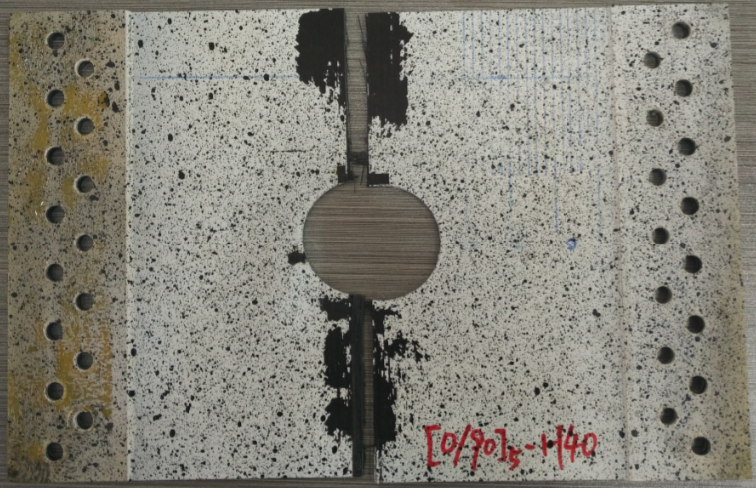 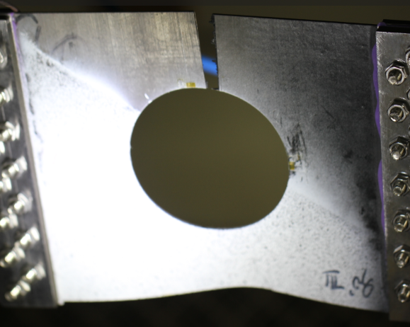 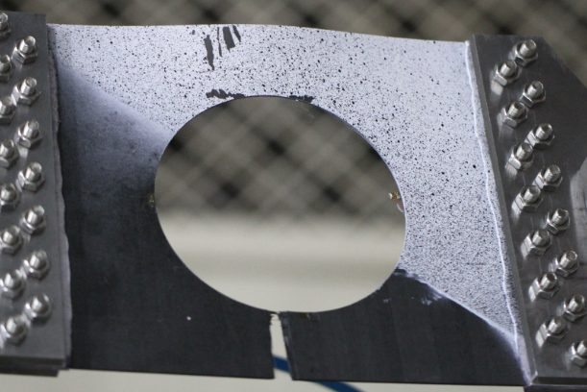

1. [0/90]5

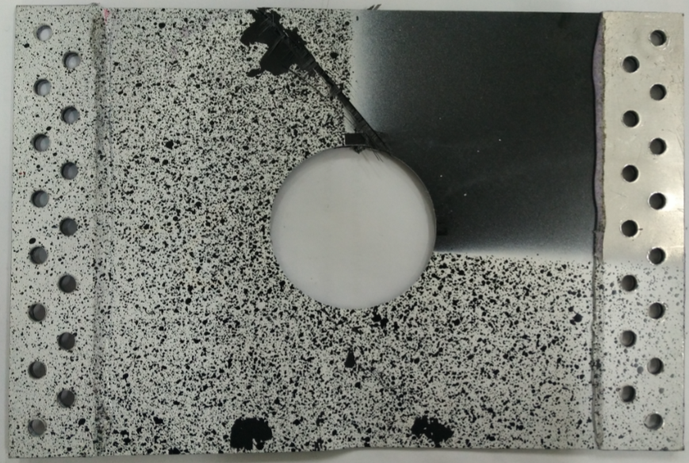 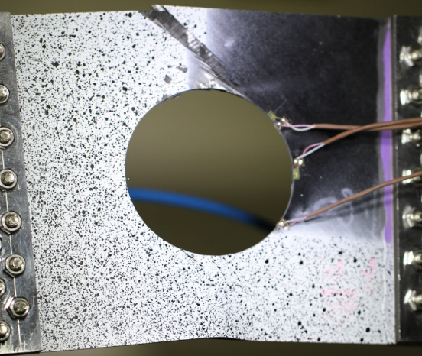 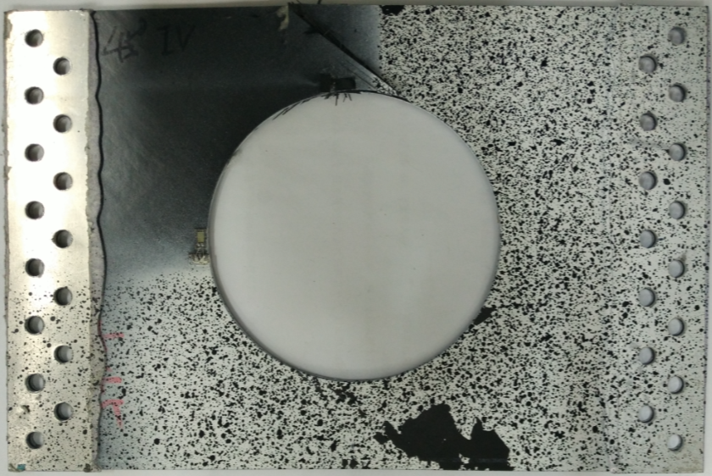

1. [±45]5

Fig.4 Failure evolution experiment result of [±45]5 laminate with cutout

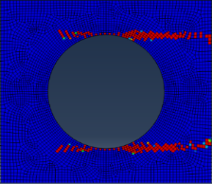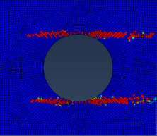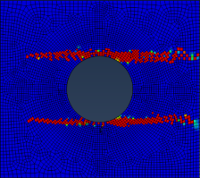

Ф=60mm Ф=80mm Ф=100mm

Fig.5 Failure evolution simulated result of [0]10 laminate with cutout

Figure 4 shows photographs of specimens taken during tensile failure. Figure 5 shows failure evolution results of [0]10 unidirectional laminates of three apertures. By comparing the results of the simulation with the experimental results in Figure 4a, we can see that [0]10 unidirectional laminates begin to have initial damage in the stress concentration area under uniaxial tensile load, and the failure mode is the matrix. tensile failure. This damage extends in the direction of tensile as the load increases, until the crack reaches the boundary of the composite laminate. The tensile load at this time reaches the ultimate load of the structure, and the load capacity drops sharply.

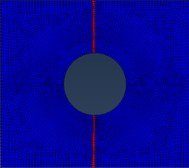 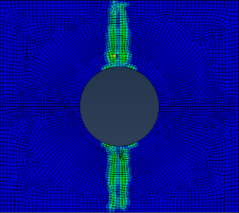

(I) fiber failure (II)matrix failure

(a) 0°ply failure evolution

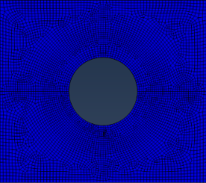 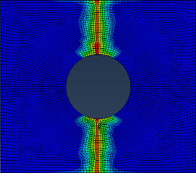

(I) fiber failure (II)matrix failure

(b) 90°ply failure evolution

Fig.6 Failure evolution simulated result of [0/90]5 laminate with 60mm cutout

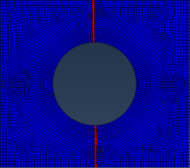 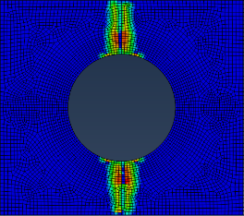

(I) fiber failure (II)matrix failure

(a) 0°ply failure evolution

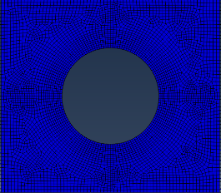 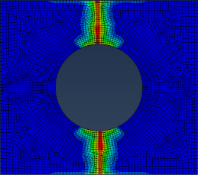

(I) fiber failure (II)matrix failure

(b) 90°ply failure evolution

Fig.7 Failure evolution simulated result of [0/90]5 laminate with 80mm cutout

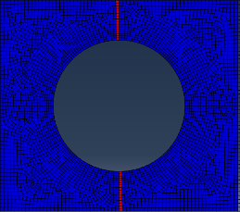 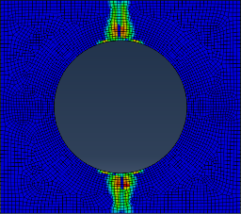

(I) fiber failure (II)matrix failure

(a) 0°ply failure evolution

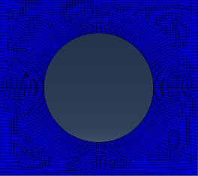 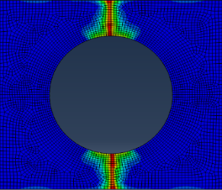

(I) fiber failure (II)matrix failure

(b) 90°ply failure evolution

Fig.8 Failure evolution simulated result of [0/90]5 laminate with 100mm cutout

Figure 6 to 8 shows failure evolution results of ${[0/90]}_{5}$ cross-ply layup laminates of three apertures. By comparing the simulated failure evolution map with the experimental results in Figure 4b, we can see that the first damage occurs in the stress concentration area at 90° layer in the cross-ply layup laminates under uniaxial tensile loading, and the failure mode is matrix tensile failure. As the load continues to increase, matrix tensile damage and fiber tensile damage occur successively in the 0° layer, and the damage locations are also in the stress concentration area at the edge of the cutout. Both of these two damage extend at the same time along the direction perpendicular to the tensile direction. On the 90° layer, the matrix tensile failure also propagates in a direction that is perpendicular to the stretching direction, but no fiber failure occurs. Finally, the fiber failure on the 0° layer and matrix failure on the 90° layer almost simultaneously extended to the boundary, implying complete failure of the structure.

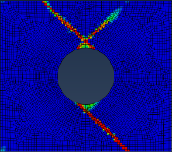 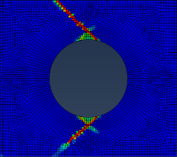 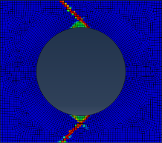

Ф=60mm Ф=80mm Ф=100mm

Fig.9 Failure evolution simulated result of [±45]5 laminate with cutout

Figure 9 shows failure evolution results of ${[45/-45]}_{5}$ angle-ply layup laminates of three apertures. By comparing the simulation results with the experimental results in Figure 4c, the failure evolution process of an angle-ply layup laminates can be summarized. Under the uniaxial tensile load, the initial damage occurs at the stress concentration area at the edge of the cutout, and the failure mode is the matrix tensile damage. Then, as the load increases, the damage extends towards the boundary in the direction of 45° along the tensile direction until the structure reaches the ultimate load. Further loading will result in complete failure of the structure.

From the entire failure evolution of the damage, it can be seen that the damage evolution processes of the three layups of composite laminates under uniaxial tensile load are different and not affected by the size of the cutouts. And the failure modes of laminates with different layups are also different. For example, ${[45/-45]}_{5}$ laminates only exhibit matrix failure, while ${[0/90]}_{5}$ laminates exhibit both matrix failure and fiber failure. The above calculation results also verify the accuracy of the calculation model used in this paper. Both the linear degradation and the exponential degradation model can accurately simulate the damage evolution of the composite laminates with big cutouts.

**2.2 Failure load calculation of laminates with big cutouts**

Through the numerical simulation can also obtain the load changes during the tensile process, Figure 10 shows the displacement load curves of composite laminates with three different layups and three different apertures. The solid and dashed lines represent the linear degradation model and the exponential degradation model respectively.

From the calculation results, it can be seen that the failure of composite laminates with big cutouts under uniaxial tensile load is brittle fracture behavior, and the results obtained by numerical calculations show that either the linear degenerate model or exponentially degenerate model can accurately simulate of brittle fracture.

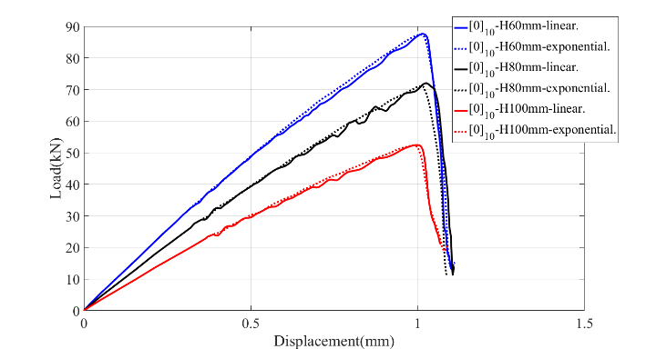

1. [0]10

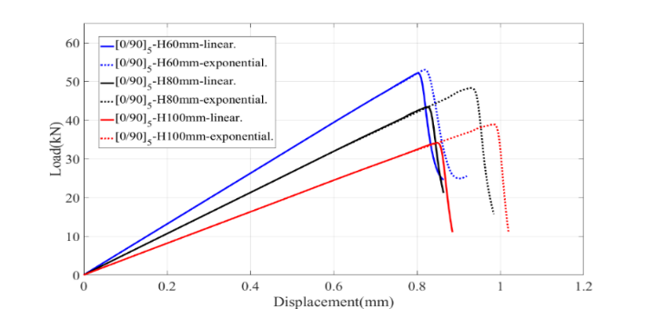

1. [0/90]5

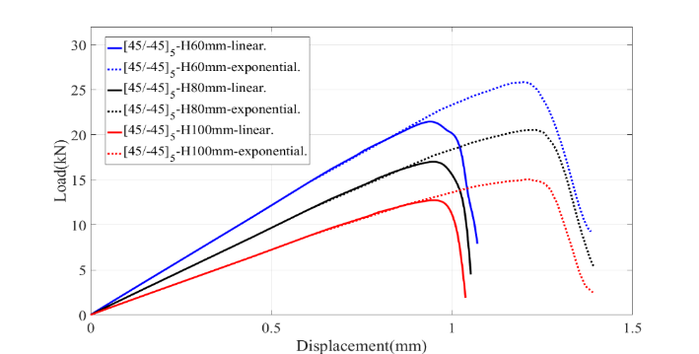

1. [±45]5

Fig.10 Load-Displacement curve calculation result of laminates with big cutouts

Table 1, Table 2 and Table 3 show the calculation results of the ultimate load of the laminates of three layups and the comparison of the experimental results. Each table gives the error comparison between the calculated results obtained using linear degradation model and exponential degradation and the experimental results. It can be seen from the data in the tables that the largest error occurs in the ${[0]}_{10}$ unidirectional laminate with 100 mm cutout. This is due to the local buckling in the experiment, and the calculation model in this paper does not consider the influence of buckling. Beyond this, the error of the calculation results of other ultimate loads is within 30%, and the error of the exponential degradation model is small with the linear degradation model.

Table.1 Ultimate Loading calculation result of [0]10 laminates

|  |  |  |  |  |  |  |  |
| --- | --- | --- | --- | --- | --- | --- | --- |
| Degradation model | 60mm | | | 80mm | | 100mm | |
| Calculation result  (KN） | error  (%) | Calculation result  (KN) | | error  (%) | Calculation result  (KN) | error(%) |
| linear degradation | 87.60 | 11.98 | | 72.00 | 3.26 | 52.42 | 49.77 |
| exponential degradation | 87.36 | 11.67 | | 71.05 | 1.89 | 52.31 | 49.46 |

Table.2 Ultimate Loading calculation result of [0/90]5 laminates

|  |  |  |  |  |  |  |
| --- | --- | --- | --- | --- | --- | --- |
| Degradation model | 60mm | | 80mm | | 100mm | |
| Calculation result  (KN） | error  (%) | Calculation result  (KN） | error  (%) | Calculation result  (KN） | error  (%) |
| linear degradation | 52.11 | 12.15 | 43.30 | 8.05 | 34.16 | 9.00 |
| exponential degradation | 53.01 | 10.64 | 48.29 | 2.26 | 38.90 | 3.62 |

Table.3 Ultimate Loading calculation result of [±45]5 laminates

|  |  |  |  |  |  |  |  |
| --- | --- | --- | --- | --- | --- | --- | --- |
| Degradation model | 60mm | | 80mm | | | 100mm | |
| Calculation result  (KN） | error  (%) | Calculation result  (KN） | error  (%) | Calculation result  (KN） | | error  (%) |
| linear degradation | 21.46 | 25.28 | 17.00 | 28.54 | | 12.74 | 27.61 |
| exponential degradation | 25.86 | 9.96 | 20.56 | 13.58 | | 15.05 | 14.49 |

Figure 11 summarizes the relationship between the aperture width ratio and the ultimate load. From the figure, it can be seen that the ultimate load value decreases with the increase of the cutout diameter, and for the laminates with the same aperture, the maximum to the minimum ultimate load is: ${[0]}_{10}$ unidirection-ply layup, ${[0/90]}_{5}$ cross-ply layup and ${[45/-45]}_{5}$ angle-ply layup. This further shows that in the composite laminates, it is the fiber that mainly carries the load. The greater the proportion of 0° layer in the direction of tensile in the laminate, the greater the carrying capacity of the laminate structure and the greater the ultimate load.

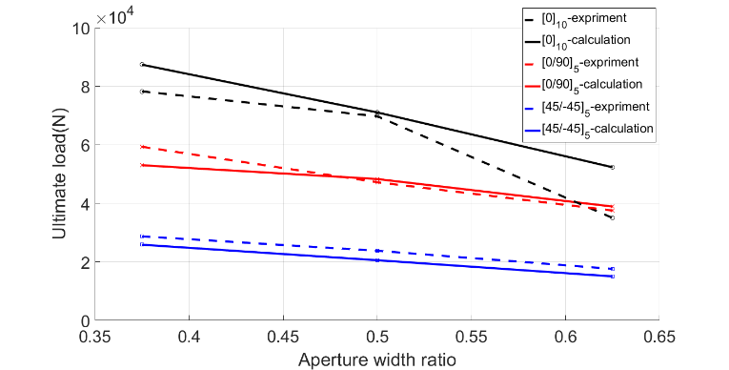

Fig.11 Relationship between diameter width ratio and ultimate loading

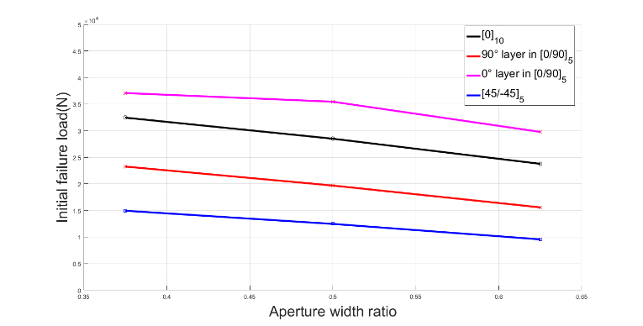

Fig.12 Relationship between diameter width ratio and initial failure loading

Figure 12 shows the relationship between the initial failure load of the laminate and the aperture width ratio. It can be obtained from the figure that the initial failure load of laminates with three layups shows a decreasing trend with the increase of the cutout diameter. When the aperture width ratio is the same, the ${[45/-45]}_{5}$ angle-ply layup laminate will be the first to damage when the tensile load increases, and the initial damage mode is the matrix tensile failure; ${[0/90]}_{5}$ cross-ply layup laminate is the second to damage, and the initial damage model was the matrix tensile failure on the 90° layer; the last damage layup was ${[0]}_{10}$ unidirection-ply layup, and the damage model was also the matrix tensile damage. However, the initial failure load of 0° layer in the ${[0/90]}_{5}$ cross-ply layup laminate is larger than the 0° layer of the ${[0]}_{10}$ unidirection-ply layup laminate. This shows that in the ${[0/90]}_{5}$ cross-ply layup laminate, due to the presence of the 90° layer, the ability of the 0° layer to carry the load is increased.

Based on the above analysis, we can see that the calculation model can accurately predict the ultimate load of laminates of three different layups under uniaxial tension. And the ultimate load calculated by the exponential degradation model is more accurate than the linear degradation model. The exponential degradation model is obviously closer to the real material.

**2.3 Failure simulation of ${[45/-45]}_{5}$ angle-ply layup laminate considering shear nonlinearity**

From the experiment, we found a nonlinear relationship between displacement and load in ${[45/-45]}_{5}$ angle-ply layup laminate. In order to accurately simulate this behavior, we consider the shear nonlinear effect in the composite material. We use the Ramberg-Osgood equation discussed above to define the shear nonlinearity in the constitutive equations and use the same model as above for numerical simulation.

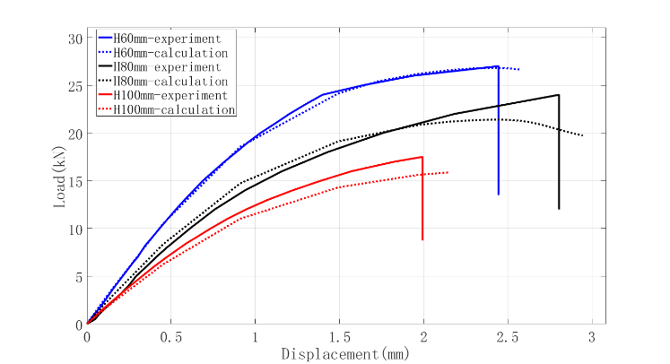

Fig.13 Load-Displacement curve calculation result of [45/-45]5 laminates considering shear nonlinearity

Figure 13 shows the displacement load curves of ${[45/-45]}_{5}$ angle-ply layup laminates obtained by calculation considering shear nonlinearity and experiment. It can be seen that the calculated results are more agreeable with the experimental results. It can accurately simulate the nonlinear phenomenon of angle-ply layup laminate in the process of uniaxial tensile.

Table.4 Comparison of Limit Loads before and after Using Shear Nonlinearity for 45/-45]5 lanimates

|  |  |  |  |  |  |  |
| --- | --- | --- | --- | --- | --- | --- |
| Degradation model | 60mm | | 80mm | | 100mm | |
| Calculation result  (KN） | error  (%) | Calculation result  (KN） | error  (%) | Calculation result  (KN） | error  (%) |
| linear degradation | 25.86 | 9.96 | 20.56 | 13.58 | 15.50 | 14.49 |
| exponential degradation | 26.81 | 6.65 | 21.39 | 10.09 | 16.01 | 9.03 |

Table 4 shows the comparison between the calculated ultimate load and the experimental ultimate load before and after considering the shear nonlinear effect. It can be seen from the table that, after considering the shear nonlinearity, the ultimate load of angle-ply layup laminate is more accurate than that without shear nonlinearity, which further explains the necessity of shear nonlinearity in numerical simulation.

**3 Conclusions**

Based on the theory of Hashin-Rotem failure criterion and continuum damage model, this paper establishes a progressive damage model. In addition, the UMAT subroutine was used in the finite element software ABAQUS to implement this model, which completely achieved the simulation of the entire process from initial failure to complete failure under uniaxial tensile load for composite laminates with big cutouts. complete failure and use shear nonlinear theory to improve the calculation model. Research indicates:

(1) Failure of composite laminates with big cutouts under uniaxial tensile loading is a brittle fracture process. Both experimental and numerical results show this phenomenon.

(2) The initial failure usually occurs in the stress concentration area, and the initial failure load decreases with the increase of the aperture. The ultimate load is affected by the layup of laminate. For laminates of the same layup, the ultimate load decreases with increasing aperture size.

(3) Damage evolution and failure modes of different layups are different. For laminates of the same layup, the failure mode and process of the damage is not affected by the aperture size. In the process of damage evolution, different failure modes can occur simultaneously in the same area.

(4) Progressive failure analysis based on the continuum damage model can effectively calculate the damage evolution process and ultimate load of the composite laminates with big cutouts under uniaxial tensile load, while the exponential degradation model can predict ultimate load more accurately than the linear degradation model. For the calculation of ${[45/-45]}_{5}$ angle-ply layup laminates, the shear nonlinear effect is introduced to make the displacement load curve result more accurate.

**References**

1 Balasubramanian M. Introduction to Composite Materials Fibrous and Textile Materials for Composite Applications. Springer Singapore, 2016:331-332.

2 DU Shanyi, GUAN Zhidong. Strategic considerations for development of advanced composite technology for large commercial aircraft in China. Acta Materiae Compositae Sinica, 2008, 25(1): 5-5.

3 Awerbuch J, Madhukar M S. Notched Strength of Composite Laminates: Predictions and Experiments--A Review. Journal of Reinforced Plastics & Composites, 1985, 4(1): 3-159.

4 Whitney J M, Nuismer R J. Stress Fracture Criteria for Laminated Composites Containing Stress Concentrations. Journal of Composite Materials, 1974, 8(3): 253-65.

5 Ochoa O O, Reddy J N. Finite Element Analysis of Composite Laminates. Nasa Sti/recon Technical Report A, 1992, 94(1): 37-109.

6 HUANG Zhengming, Zhang Huashan. Current Status and Future Trend of Researches on the Strength of Fiber-Reinforced Composite-A Summary of the Results From A “Failure Olympics”. Advances In Mechanics, 2007, 37(1): 80-98.

7 Tsai S W, Wu E M. A General Theory of Strength for Anisotropic Materials. Journal of Composite Materials, 1971, 5(1): 58-80.

8 Hashin Z, Rotem A. A Fatigue Failure Criterion for Fiber Reinforced Materials. Journal of Composite Materials, 1973, 7(4): 448-64.

9 Puck A, Schürmann H. Failure analysis of FRP laminates by means of physically based phenomenological models. Composites Science & Technology, 2002, 62(12–13): 1633-62.

10 Poon C, Shokrieh M M, Lessard L B. Three-Dimensional Progressive Failure Analysis of Pin/Bolt Loaded Composite Laminates. 1996,

11 Krajcinovic D K. Continuum damage mechanics. 1984, 37(1): 1-6.

12 Camanho P M P R D C. Application of numerical methods to the strength of mechanically fastened joints in composite laminates. Wear, 1999, 5(2): 114-35.

13 Camanho P P, Matthews F L. Stress analysis and strength prediction of mechanically fastened joints in FRP: a review. Composites Part A Applied Science & Manufacturing, 1997, 28(6): 529-47.

14 Shahid I, Chang F K. Accumulative damage model for tensile and shear failures of laminated composite plates. Journal of Composite Materials, 1995, 29(7): 926-81.

15 Chang F K, Chang K Y. A Progressive Damage Model for Laminated Composites Containing Stress Concentrations. Journal of Composite Materials, 1987, 21(9): 834-55.

16 Ladeveze P, Ledantec E. Damage modelling of the elementary ply for laminated composites. Composites Science & Technology, 1992, 43(3): 257-67.

17 Maimí P, Camanho P P, Mayugo J A, et al. A continuum damage model for composite laminates: Part II – Computational implementation and validation. Mechanics of Materials, 2007, 39(10): 909-19.

18 Lapczyk I, Hurtado J A. Progressive damage modeling in fiber-reinforced materials. Composites Part A Applied Science & Manufacturing, 2007, 38(11): 2333-41.

19 Lee C S, Kim J H, Kim S K, et al. Initial and progressive failure analyses for composite laminates using Puck failure criterion and damage-coupled finite element method. Composite Structures, 2015, 121(406-19.

20 Bažant Z P, Oh B H. Crack band theory for fracture of concrete. Matériaux Et Construction, 1983, 16(3): 155-77.

21 Chamis C C, Sinclair J H. Ten-deg off-axis test for shear properties in fiber composites. Experimental Mechanics, 1977, 17(9): 339-46.

22 Swanson S R, Messick M, Toombes G R. Comparison of torsion tube and Iosipescu in-plane shear test results for a carbon fibre-reinforced epoxy composite. Composites, 1985, 16(3): 220-4.

23 Weinberg M. Shear testing of neat thermoplastic resins and their unidirectional graphite composites. Composites, 1987, 18(5): 386-92.

24 Hahn H T, Tsai S W. Nonlinear Elastic Behavior of Unidirectional Composite Laminae. Journal of Composite Materials, 1973, 7(1): 102-18.

25 Paepegem W V, Baere I D, Degrieck J. Modelling the nonlinear shear stress–strain response of glass fibre-reinforced composites. Part I: Experimental results. Composites Science & Technology, 2006, 66(10): 1455-64.

26 Chang F K, Lessard L B. Damage Tolerance of Laminated Composites Containing an Open Hole and Subjected to Compressive Loadings: Part I--Analysis. Journal of Composite Materials, 1991, 25(1): 44-64.

27 LIU Weiguang, YU Yin, WANG Hai. A Damage Model Considering Shear Nonlinearity for Progressive Failure Analysis of Composite Laminates. Journal of Shanghai Jiao Tong University, 2016, 50(2): 194-9.

28 Blacklock J R, Richard R M. Finite element analysis of inelastic structures. Aiaa Journal, 2015, 7(7):432-438.